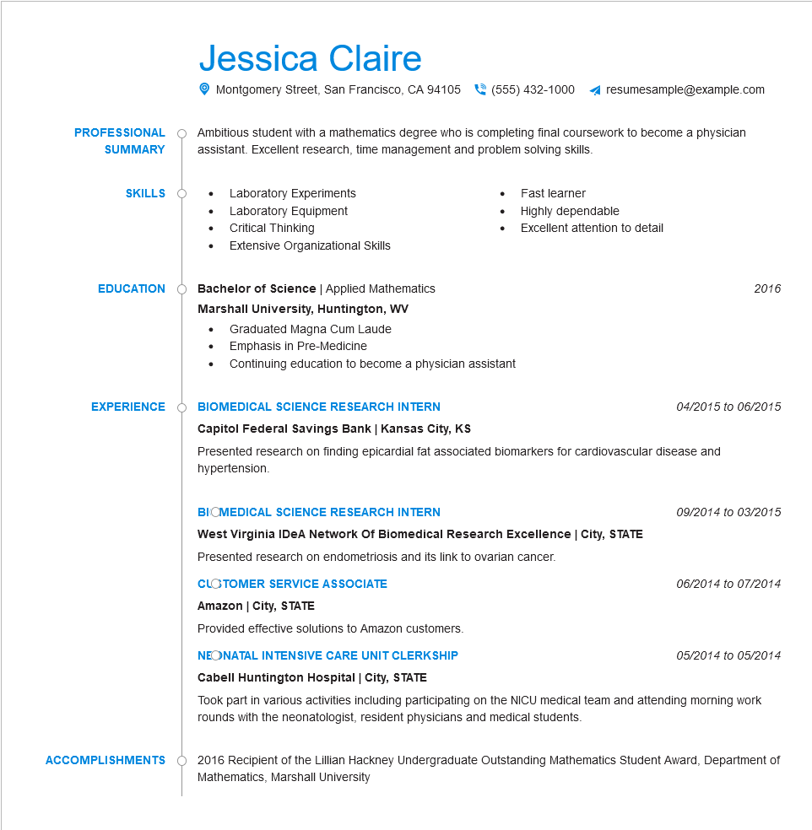
PROFESSIONAL
SUMMARY
Jessica Claire
Montgomery Street, San Francisco, CA 94105
(555) 432-1000
resumesample@example.com
Ambitious student with a mathematics degree who is completing final coursework to become a physician assistant. Excellent research, time management and problem solving skills.
• Laboratory Experiments
SKILLS
•
Fast learner
Laboratory Equipment
•
Highly dependable
Critical Thinking
•
Excellent attention to detail
Extensive Organizational Skills
EDUCATION
Bachelor of Science | Applied Mathematics
Marshall University, Huntington, WV
•
Graduated Magna Cum Laude
• Emphasis in Pre-Medicine
Continuing education to become a physician assistant
EXPERIENCE
BIOMEDICAL SCIENCE RESEARCH INTERN
Capitol Federal Savings Bank | Kansas City, KS
2016
04/2015 to 06/2015
Presented research on finding epicardial fat associated biomarkers for cardiovascular disease and hypertension.
ACCOMPLISHMENTS
BIOMEDICAL SCIENCE RESEARCH INTERN
West Virginia IDeA Network Of Biomedical Research Excellence | City, STATE Presented research on endometriosis and its link to ovarian cancer.
CLOTOMER SERVICE ASSOCIATE
Amazon | City, STATE
Provided effective solutions to Amazon customers.
NEONATAL INTENSIVE CARE UNIT CLERKSHIP
Cabell Huntington Hospital | City, STATE
09/2014 to 03/2015
06/2014 to 07/2014
05/2014 to 05/2014
Took part in various activities including participating on the NICU medical team and attending morning work rounds with the neonatologist, resident physicians and medical students.
2016 Recipient of the Lillian Hackney Undergraduate Outstanding Mathematics Student Award, Department of Mathematics, Marshall University

